

**Four Seasons in One Dance**

**By Shantisha**

**This spectacular fusion belly dance performance will immerse you in all the four seasons in just one dance. One by one, beat by beat, move by move… Breathtaking, enticing, unforgettable. You will totally love it!**

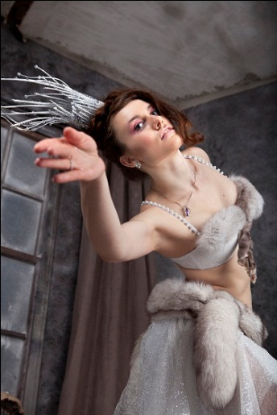Find Shantisha on The Busking Project (to donate money to the show press the ‘give’ button on the right of the page) <http://thebuskingproject.com/busker/2271>

**Show times & dates (August 2014)**

|  |  |  |
| --- | --- | --- |
| **Date** | **Time** | **Venue** |
| 1st August, Friday | 13:30 | Mound Busker 1 |
| 2nd August, Saturday | 15:45 | Mercat Stage |
| 6th August, Wednesday | 16:30 | Mercat Stage |
| 8th August, Friday | 13:30 | Mound Busker 1 |
| 12th August, Tuesday | 15:00 | Mercat Stage |
| 14th August, Thursday | 15:45 | Mercat Stage |
| 18th August, Monday | 13:30 | Mound Busker 1 |
| 21st August, Thursday | 13:30 | Mound Busker 1 |
| 24th August, Sunday | 15:00 | Mercat Stage |
|  |  |  |

**How to find the venues:**

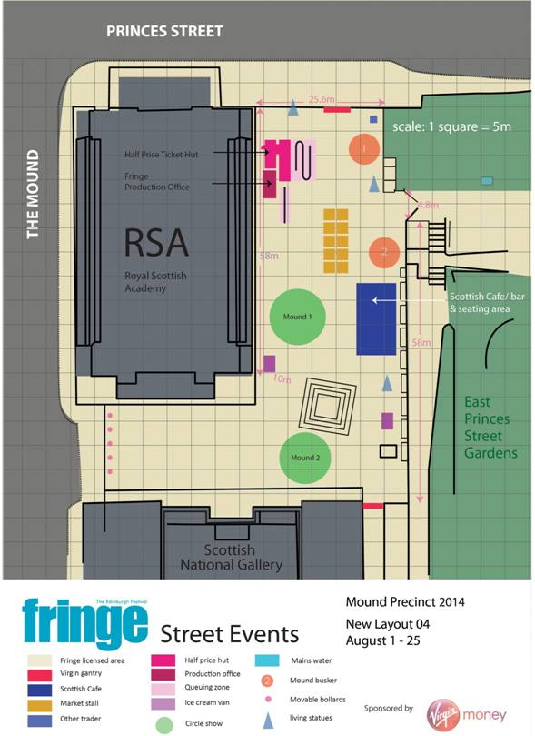The Mercat stage is tucked between the Mercat Cross and St Giles Cathedral, right next to the Fringe Street Events office (close to the Fringe Shop and Box Office).

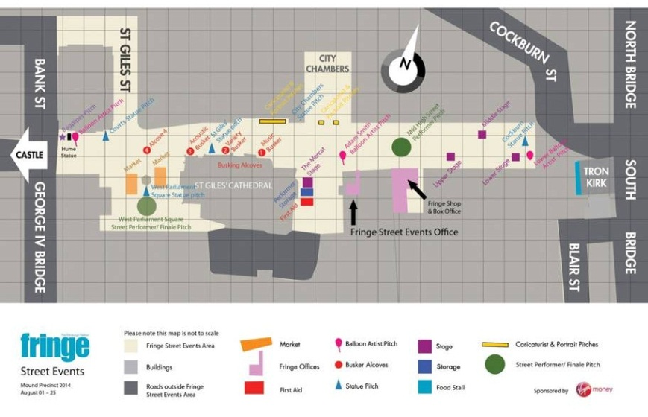Mound Busker 1 is down on the Mound by the National Galleries.